School of Computer Science and Engineering,
Department of Computer Science and Application, MIT-WPU
MENTOR MENTEE RECORD AY 2026 - 2027
(PART A)
- Student Information
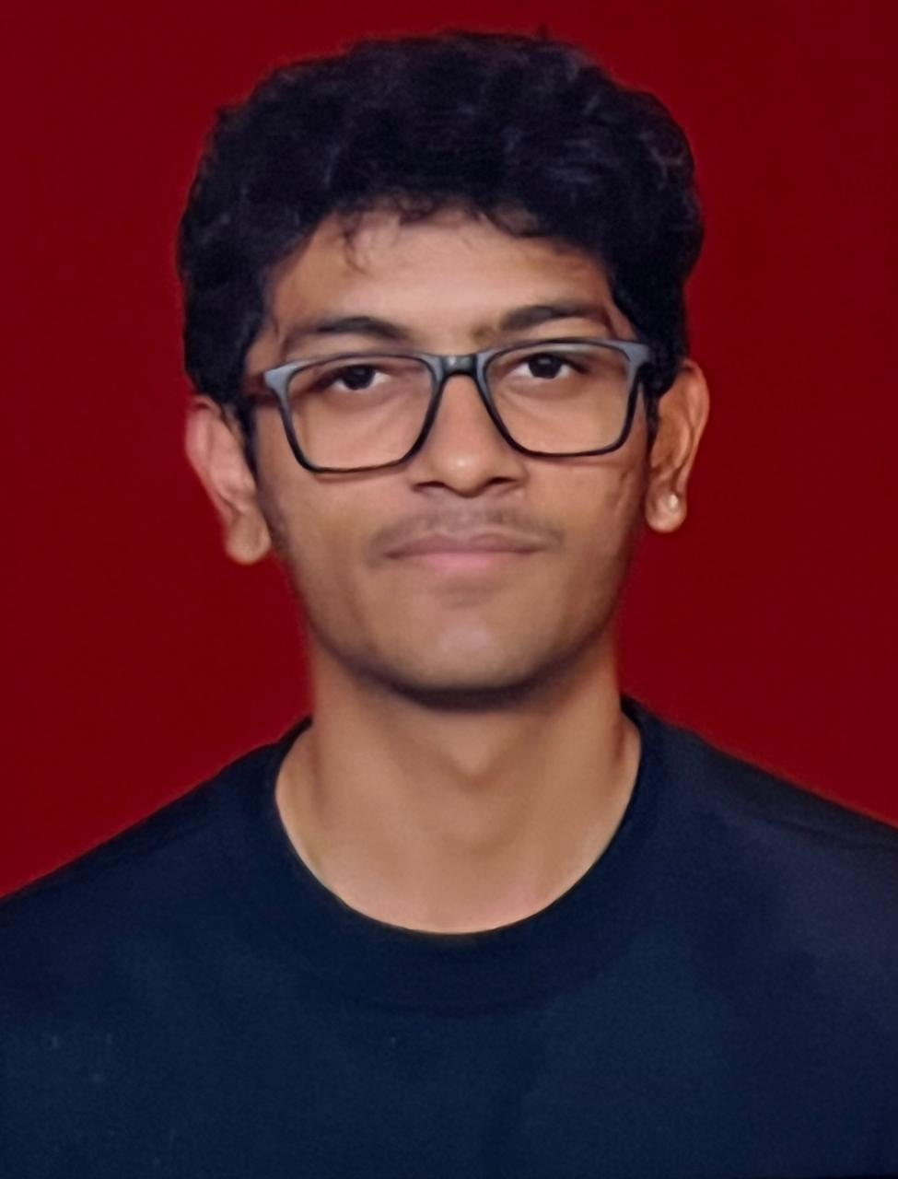sport size photo
Passport size photo

Full Name: Vedant Khedkar
PNR: 1272240644
Programme: BCA Year: 3
Email Address: vedant.khedkar@mitwpu.edu.in
Email Address: vedantkhedkar007@gmail.com
Phone Number: +919022612342
Date of Birth: 09/08/2006 Gender: Male
Permanent Address: Mansi Vishwas Nagar A-409 Nahre - 41
Correspondence Address: Mansi Vishwas Nagar A-409 Nahre - 41
- Parents/Guardians Details:
Full Name: Dilip Khedkar
Relationship: Father Contact Number: 9923796438
Email Address:
- Mentor Information
Full Name: Amit Kumar Mishra
Position/Title: Class Teacher Phone Number: 93250 22612
Email Address: amit.mishra@mitwpu.edu.in
- Counselling & Support Services:
Our University has a Counselling Centre (Aakriti: Centre for Holistic Well-Being, Ground floor, Maitreyi building) that provides confidential support for academic stress, emotional wellbeing, and personal challenges.
Students may approach directly, or mentors may refer if needed. Services are free, professional, and confidential.

Mentee Acknowledgement:
I am aware of the Counselling Centre and understand I can approach it anytime if I need support.
Signature of Mentee: 
Date: 23/08/2026

Acknowledgement by Student
I, Vedant Khedkar, PNR:1272240644, hereby confirm that I have read and understood my roles, responsibilities, and conduct guidelines as outlined in the following documents of MIT-WPU:
- MIT-WPU Students Manual
- Students Housing Manual (if applicable)
- Examination Ordinance
- Escalation Matrix at MIT-WPU
I acknowledge that:
- I am responsible for adhering to the rules, regulations, and codes of conduct mentioned in the above documents.
- I will reach out to the concerned authorities in case of any clarification required.
- I understand that violation of these guidelines may invite disciplinary action as per University policies.
Student Declaration:
By signing below, I confirm my acceptance and commitment to comply with the above.

Date and Signature of Student: 23-08-2026

Name of Student: Vedant Khedkar

PART B
Monthly meetings

Instructions: For each session, mentors may tick relevant boxes and add brief notes.

Date | Session No. | Focus Area (tick/√) | Key Notes (Progress, Concerns, Achievements) | Action Plan / Follow-up | Student Response (Motivated / Neutral / Concerned) | Student’s sign
Aug | Session 1 | Academic/ Career/ Personal/ Well-being |  |  | Motivated | 
Aug | Session 2 | Academic/ Career/ Personal/ Well-being |  |  | Motivated | 
Sep | Session 3 | Academic/ Career/ Personal/ Well-being |  |  | Motivated / Neutral / Concerned
Sep | Session 4 | Academic/ Career/ Personal/ Well-being |  |  | Motivated / Neutral / Concerned
Oct | Session 5 | Academic/ Career/ Personal/ Well-being |  |  | Motivated / Neutral / Concerned
Date | Session No. | Focus Area (tick/√) | Key Notes (Progress, Concerns, Achievements) | Action Plan / Follow-up | Student Response (Motivated / Neutral / Concerned) | Student’s sign
Oct | Session 6 | Academic/ Career/ Personal/ Well-being |  |  | Motivated / Neutral / Concerned
Nov | Session 7 | Academic/ Career/ Personal/ Well-being |  |  | Motivated / Neutral / Concerned
Nov | Session 8 | Academic/ Career/ Personal/ Well-being |  |  | Motivated / Neutral / Concerned
Dec | Session 9 | Academic/ Career/ Personal/ Well-being |  |  | Motivated / Neutral / Concerned
Dec | Session 10 | Academic/ Career/ Personal/ Well-being |  |  | Motivated / Neutral / Concerned
Jan | Session 11 | Academic/ Career/ Personal/ Well-being |  |  | Motivated / Neutral / Concerned
Date | Session No. | Focus Area (tick/√) | Key Notes (Progress, Concerns, Achievements) | Action Plan / Follow-up | Student Response (Motivated / Neutral / Concerned) | Student’s sign
Jan | Session 12 | Academic/ Career/ Personal/ Well-being |  |  | Motivated / Neutral / Concerned
Feb | Session 13 | Academic/ Career/ Personal/ Well-being |  |  | Motivated / Neutral / Concerned
Feb | Session 14 | Academic/ Career/ Personal/ Well-being |  |  | Motivated / Neutral / Concerned
Mar | Session 15 | Academic/ Career/ Personal/ Well-being |  |  | Motivated / Neutral / Concerned
Mar | Session 16 | Academic/ Career/ Personal/ Well-being |  |  | Motivated / Neutral / Concerned
Apr | Session 17 | Academic/ Career/ Personal/ Well-being |  |  | Motivated / Neutral / Concerned
Date | Session No. | Focus Area (tick/√) | Key Notes (Progress, Concerns, Achievements) | Action Plan / Follow-up | Student Response (Motivated / Neutral / Concerned) | Student’s sign
Apr | Session 18 | Academic/ Career/ Personal/ Well-being |  |  | Motivated / Neutral / Concerned
May | Session 19 | Academic/ Career/ Personal/ Well-being |  |  | Motivated / Neutral / Concerned
May | Session 20 | Academic/ Career/ Personal/ Well-being |  |  | Motivated / Neutral / Concerned

Referral Tracking (Mentor to fill if applicable):
- ☐ Student was referred for counselling on date_______________________
- ☐ No referral required

PART C
Institutional Feedback from student

(Mid-Semester review)
(Prompts: What worked well for you? What challenges did you face?)

Area | What Helped | What Needs Improvement
Teaching–Learning
Curriculum & Assessment
Support Systems (LMS, Infra, Library)
Activities & Engagement
Career Guidance & Internships
Well-being & Counselling

(End-Semester review)

Area | What Helped | What Needs Improvement
Teaching–Learning
Curriculum & Assessment
Support Systems (LMS, Infra, Library)
Activities & Engagement
Career Guidance & Internships
Well-being & Counselling

PART D
Mentee Growth Rubric (Student Self-Assessment) end of AY
(Rating Scale: 1 = Not at all, 5 = Excellent)
Growth Dimension | Rating (1–5) | Example / Remark
Academic Confidence & Results (e.g., GPA, clarity in subjects)
Time Management & Study Habits (planning, deadlines)
Emotional Balance & Stress Handling (coping skills)
Communication & Peer Interaction (group work, openness)
Career Awareness & Readiness (internships, CV prep)

Outcomes of mentoring

- Academic Perspective

Statement | Strongly Agree | Agree | Disagree | Strongly Disagree | Can’t Say
Improved subject confidence & knowledge
Better understanding of assessments
Improved time management

- Emotional & Psychological Perspective

Statement | Strongly Agree | Agree | Disagree | Strongly Disagree | Can’t Say
Reduced behavioural concerns
Improved self-control & self-image
Enhanced empathy with peers
Better decision-making
Improved emotional balance
Recognition of peers’ achievements

- Personality Shaping Perspective

Statement | Strongly Agree | Agree | Disagree | Strongly Disagree | Can’t Say
Cultivating gratitude
Increased perseverance & consistency
More optimistic outlook
Healthier listening skills
Enhanced competencies

PART E
Mentor’s Closing Report

Dimension | Issues Identified | Actions Taken | Progress Observed | Recommendation for Next Year
Academic
Personal/Well-being
Career & Skills

Overall Progress: ☐ Excellent ☐ Good ☐ Fair ☐ Needs Attention

Final Undertaking
Mentee Statement
The mentor–mentee interactions during the graduate years have helped me explore my strengths and skill sets, while also managing challenges such as anxiety and stress. The mentoring process has improved my outlook toward academics, personal development, and life skills. I understand my role as an alumnus is significant in supporting the University, and I am committed to contributing to MIT-WPU as a proud graduate.

Mentor's Name & Signature Date:


Mentee's Name & Signature : - Vedant Khedkar
Date: 23-06-2026

Reminder: Students may approach the Counselling Centre anytime for support.
Reminder: Students may approach the Counselling Centre anytime for support.

